Motion Mapping with Your iPhone

Physicists describe motion in one dimension (along a line) with graphs. Motion can be described by illustrating where an object is at what moments, as well as how fast and in what direction an object is moving. This information is contained in position-time (x-t) graphs, and some of this information can also be represented in corresponding velocity-time (v-t) graphs.

The exercises in this lab will help you transfer your physical conceptions of motion into these more abstract, but useful graphical representations.


Important Notes

- You can save evidence of your work by taking screen captures. Access these screen captures from the Gallery.
- Take screen captures by holding down the volume up button and the side button at the same time, and release quickly.
- Walk with your phone at arm’s-length during the activity.
- Trouble with the app? “Kill” it and restart the app as a first resort.

A. Free play
Access the Physics Toolbox Sensor Suite on an iPhone 12, 13, or 14 Pro/Pro Max. This app has a number of features that access the smartphone’s sensors directly. From the main menu, select Motion Visualizer, which uses LiDAR technology (lasers) to calculate the distance to an object in the camera’s field of view.

Within the Motion Visualizer, click on the Chart feature in the bottom menu bar. (Do not yet click on any other menu items).

You may find that having a few meter sticks at hand may be helpful to completing the exercises in this lab.

Explore position-time and velocity-time graphs by moving back and forth from any flat wall in the lab space. Think about how your motion affects what is produced on the graph.

Q0. In general, what patterns do you notice about your motion and the kind of shapes your motion produces on position-time and velocity-time graphs?

B. Graph Match Challenge
This section will entail a multi-level challenge that will work through the concepts of kinematics. Click on the “Game” feature in the lower menu.

Level 1: Positive slope
Play Level 1 in the app and answer the following question about the graphs you made:

Q1: What does the slope of a graph tell you about an object’s motion? Explain how you know.

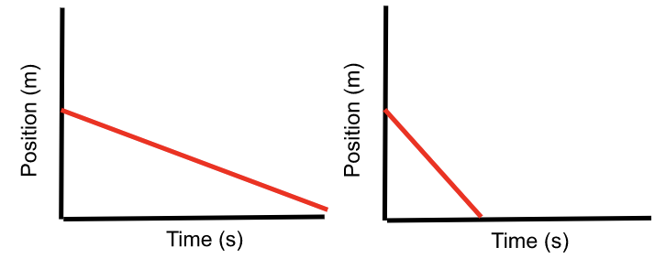

Level 2: Negative slope
Play Level 2 in the app and answer the following question about the graphs you made:

Q2: What did you have to do differently to get the graphs with negative slopes on Level 2 (compared to the graphs with positive slopes on Level 1)? Summarize what the slope of a graph can tell you about an object’s motion.

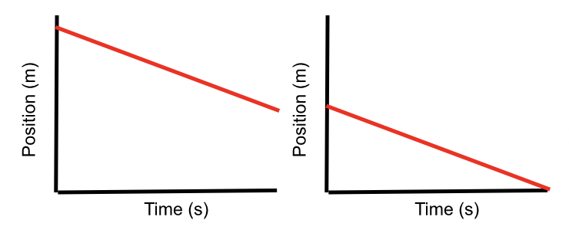

Level 3: Starting position
Play Level 3 in the app and answer the following question about the graphs you made:

Q3: What did you have to do differently to produce each of the two graphs in Level 3? Summarize what the y-intercept of a graph can tell you about an object’s motion.

Level 4: Walk a path
Play Level 4 in the app and answer the following question about the graphs you made:

Q4: Describe, in words, how you would explain to someone else how to produce these graphs by “walking out” their motion.
Graph 1
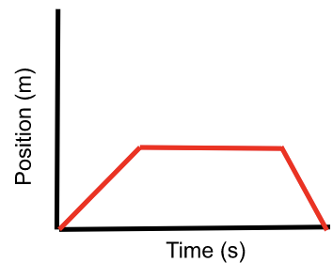
Graph 2
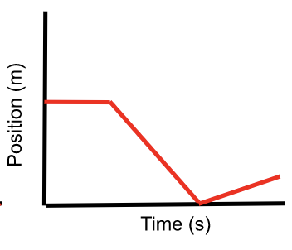
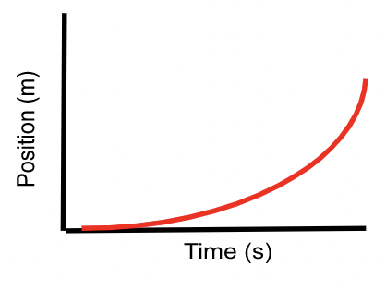

Level 5: Changing Positive Slope
Play Level 5 in the app and answer the following question about the graph you made:

Q5: Explain the difference between the motion that produces a straight-line graph with a positive slope and this curved-line graph.

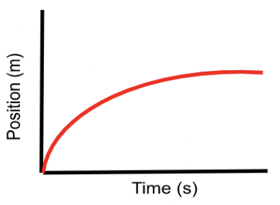

Level 6: Changing Positive Slope…again!
Play Level 6 in the app and answer the following question about the graph you made:

Q6: Describe the kind of motion you had to undergo to produce this graph.

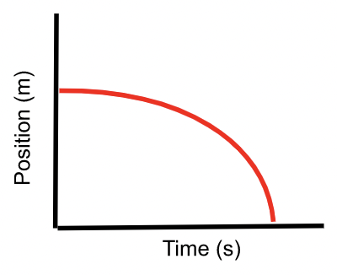

Level 7: Changing Negative Slope
Play Level 7 in the app and answer the following question about the graph you made:

Q7: Describe the kind of motion you had to undergo to produce this graph.

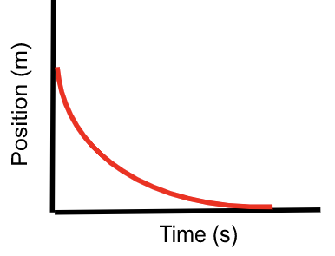

Level 8: Changing Negative Slope…yes, again.
Play Level 8 in the app and answer the following question about the graph you made:

Q8: Describe the kind of motion you had to undergo to produce this graph.

Level 9: The Final Boss
Play Level 9 in the app and answer the following question:
Q9: Describe, in words, how you would explain to someone else how to produce these graphs by “walking out” their motion.
Graph 1
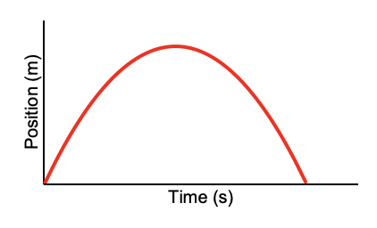
Graph 2
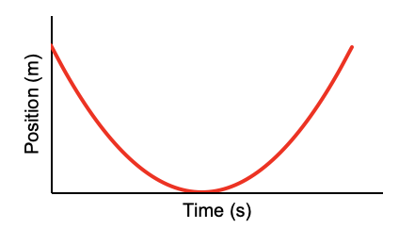

3. Synthesizing What You’ve Learned
Now, think about how you can affect the position and velocity graphs by changing your motion. Throughout this activity, you have observed primarily position-time graphs. Now, open a velocity-time graph so you can compare position-time and velocity-time graphs together. Collect a few plots that show the effects that changing positions, velocities, and accelerations might have on your motion graphs. Try to make your graphs as clear as possible!

Q10: Look back at your original response to Q0, and write an improved response below: In general, what patterns do you notice about your motion and the kind of shapes your motion produces on position-time and velocity-time graphs?

